**Descargar e instalar flutter**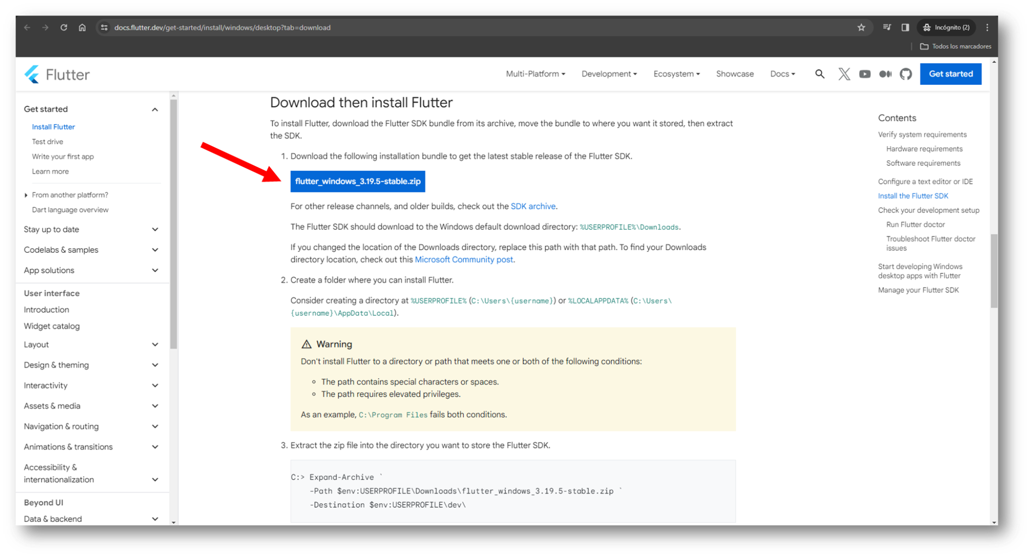

**Descargar:**

[1]. <https://docs.flutter.dev/get-started/install/windows/desktop?tab=download>

[2]. <https://storage.googleapis.com/flutter_infra_release/releases/stable/windows/flutter_windows_3.19.5-stable.zip>